

Topic test 1
Name: __________________________________

Chapter 4: Recurrence relations

- Time allowed: 45 minutes
- CAS calculators may be used.
- Part A: 5 multiple-choice questions (5 marks)
- Part B: 6 short-answer questions (15 marks)
- Part C: 1 analysis question (15 marks)
Part A
Multiple-choice questions
5 multiple-choice questions
1 mark each: 5 marks
Circle the correct answer.
1 The first four terms of a sequence are given below.
4, 6, 10, 18
A recurrence relation that can be used to generate this sequence is:
A tn+1 = tn + 2 t1 = 4
B tn+1 = 1.5tn t1 = 4
C tn+1 = 0.5tn + 4 t1 = 4
D tn+1 = 2tn  2 t1 = 4
E tn = tn 1 + tn 2 t1 = 4, t2 = 6

[1 mark]
2 A recurrence relation for a sequence is wn = 5wn –1  50. If w4 = 650, then w2 is equal to:
A 38
B 120
C 140
D 3200
E 15 950

[1 mark]
3 A sequence is described by the recurrence relation tn+1 = tn  3 where t1 = 18. The nth term of this sequence is given by:
A tn = 21  n
B tn = 15  3n
C tn = 18  n
D tn = 18  3n
E tn = 21  3n

[1 mark]
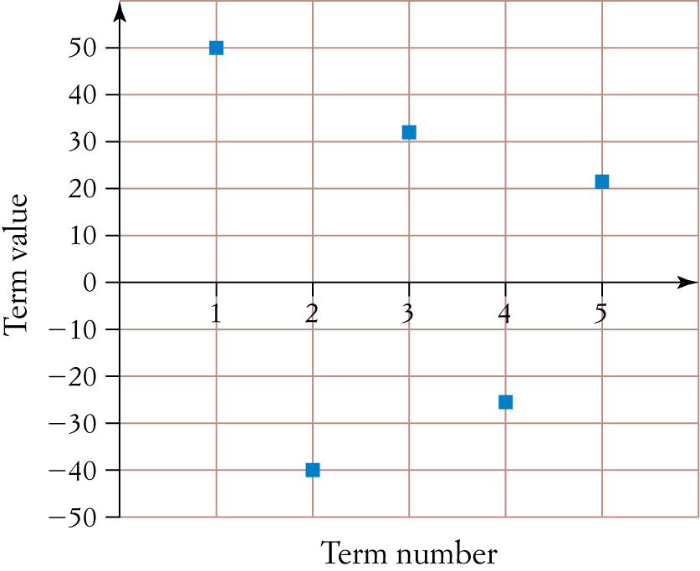
4

The values of the first five terms of a sequence are plotted on the graph above. A recurrence relation that could apply to this sequence is:
A tn+1 = 0.8tn t1 = 50
B tn+1 = 0.8tn t1 = 50
C tn+1 = 10  tn t1 = 50
D tn+1 = 1.2tn t1 = 50
E tn+1 = 1.2tn t1 = 50

[1 mark]
5 When first introduced to a chicken coup, the height of a baby chicken was 10.2 centimetres. During its first month, the chicken’s height increased by 6.4 centimetres.
During its nth month, the height of the chicken increased by Hn centimetres where Hn+1 = 0.8Hn.
The maximum height to which the chicken can grow, in centimetres, is closest to:
A 18.2
B 19.2
C 32
D 42.2
E 83

[1 mark]
Part B
Short-answer questions
6 short-answer questions
15 marks
Show your working where appropriate.
1 Write down the first five terms of the sequence defined by the recurrence relation:
tn+1 = 5tn  4 t1 = 2

[2 marks]
2 A sequence is defined by the rule tn = 80  0.6n–1, n = 1, 2, 3, …
Write a recurrence relation that describes the same sequence.

[2 marks]
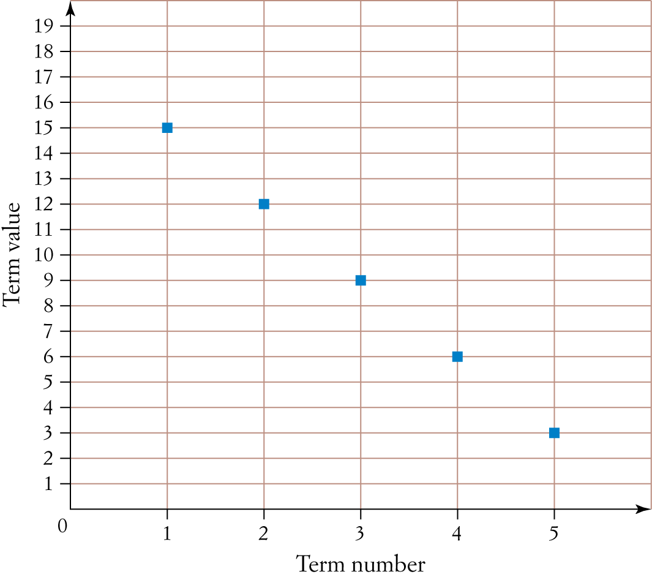
3 The graph below shows the first five terms of a recurrence relation.
a Write the recurrence relation.

b What is the gradient of the line that passes through these five points?

[3 marks]
4 The nth term of an arithmetic sequence is given by the rule:
tn = 16  2n n = 1, 2, 3, …
Find the recurrence relation.

[2 marks]
5 A colony of algae increases in size by 20% each week. There are initially 20 grams of algae in a lake.
a Find a recurrence relation that represents the size of the algae colony each week.

b Once the algae colony reaches a mass of 12 000 grams, the lake is no longer suitable for human use. After how many weeks will the lake first be unsuitable for use by humans?

[3 marks]

6 Maggie invests $4000 in a savings account that earns 6% per annum simple interest.
a How much interest is earned each year?

b Find a recurrence relation that gives the amount in Maggie’s savings account after n years.

[3 marks]
Part C
Analysis question
1 analysis question
15 marks
Show your working where appropriate.
1 Amity opens an online gift shop. In the first month, she sold 32 imported French candles from her stock. In the second month, 28 candles were sold and in the third month, 24 were sold. This pattern continued until all of the candles in stock were sold.
The number of candles sold each month form an arithmetic sequence:
32, 28, 24, …
a A rule describing this sequence is Cn+1 = Cn  y where C1 = 32. State the value of y.

b How many imported candles were sold in the fifth month after opening?

c How many fewer candles were sold in the sixth month than in the fourth month?

d i How many candles were sold in the first 6 months after opening?

ii How many of the candles in stock had not been sold after 6 months?

In the first month after Amity’s gift shop opened, she received 16 orders for personalised coffee mugs. After the first month, the number of personalised coffee mug orders each month forms a geometric sequence with a common ratio of 2.5.
The sequence that describes the number of personalised coffee mug orders in the nth month after the shop opened can be written as the recurrence relation:
Mn+1 = aMn + b M1 = k
e Write the values of a, b and k.

f How many orders for the personalised coffee mugs did the store receive in the third month
after opening?

g How many personalised coffee mugs were ordered in total in the first 4 months after opening?

Amity uses the following recurrence relation to model the profit, in dollars, Pn, made by her online gift store at the end of the nth year after opening.
Pn+1 = 0.95Pn + 1000 P1 = 8000
h What is the profit made at the end of the third year after the shop opens?

i At the end of which year after the shop opens does the profit first exceed $13 000?

j According to this model, what is the largest possible profit that can be made in a year?

[15 marks]
[Total marks: 35]

Answers
Part A – Multiple-choice questions [1 mark each]
1 The first term is 4, so t1 = 4.
Each term in the sequence is 2 less than double the previous term.
2  4  2 = 6
2  6  2 = 10
2  10  2 = 10
∴ tn+1 = 2tn  2 t1 = 4
∴ D
2 w4 = 5w3  50
650 = 5w3  50
700 = 5w3
w3 = 140
w3 = 5w2  50
140 = 5w2  50
190 = 5w2
w2 = 38
∴ A
3 The recurrence relation represents an arithmetic sequence with a = 18 and d = 3.
tn = a + (n  1)d
= 18  3(n  1)
= 18  3n + 3
= 21  3n
∴ E
4 The sequence is geometric with t1 = 50 and r = 0.8 which is most easily found by 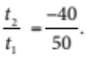
The recurrence relation is therefore tn+1 = 0.8tn t1 = 50
∴ B
5 The growth sequence is geometric with r = 0.8 and a = 6.4.
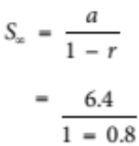
= 32
The maximum possible height of the chicken is 32 + 10.2 = 42.2 cm.
∴ D
Part B – Short-answer questions
1 2, 14, 74, 374, 1874 [1 mark for two correct, 2 marks for five correct]
2 tn+1 = 0.6tn [1 mark] t1 = 80  0.60 = 80 [1 mark]
3 a tn+1 = tn  3 [1 mark] t1 = 15 [1 mark]
b Gradient = 3 [1 mark]
4 tn+1 = tn  2 [1 mark] t1 = 14 [1 mark]
5 a tn = 1.2tn₂1 [1 mark] t0 = 20 [1 mark]
b t36 = 14 176.037 499 68 grams
The lake is first unsuitable for use by humans after 36 weeks. [1 mark]
6 a 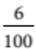  4000 = 240
Each year, $240 is earned in interest. [1 mark]
b tn = tn₂1 + 240 [1 mark] t0 = 4000 [1 mark]
OR equivalent
Part C – Analysis question
1 a A rule describing this sequence is Cn+1 = Cn  y where C1 = 32. State the value of y.
y = 4 [1 mark]
b C4 = 24  4
= 20
C5 = 20  4
= 16 [1 mark]
c Four fewer candles are sold in the fifth month than in the fourth month, and four fewer are sold in the
sixth month than in the fifth month.
Therefore, eight fewer candles are sold in the sixth month than in the fourth month. [1 mark]
d i a = 32, d = 4
Sn = [2a + (n  1)d]
S6 = [2  32 + 5  4]
= 132 [1 mark]
ii The last term in the sequence is 4.
∴ Cn = 4
32 + (n  1)  4 = 4
n = 8 [1 mark]
The total number of candles in stock is S8.
Sn = [2a + (n  1)d]
S8 = [2  32 + 7  4]
= 144
After 6 months, 144  132 = 12 candles had not been sold. [1 mark]
e a = 2.5 [1 mark]
b = 0 [1 mark]
k = 16 [1 mark]
f M2 = 2.5  16
= 40
M3 = 2.5  40
= 100
∴ The store received 100 orders for personalised coffee mugs in the third month after opening. [1 mark]
g M4 = 2.5  100
= 250
Total mugs ordered in the first 4 months after opening
= 16 + 40 + 100 + 250
= 406 [1 mark]
h P2 = 0.95  8000 + 1000
= 8600
P3 = 0.95  8600 + 1000
= 9170
The profit made at the end of the third year is $9170. [1 mark]
i At the end of the 12th year, the profit is $13 174. So, at the end of the 12th year, the profit
first exceeds $13 000. [1 mark]
j Let x be the maximum possible profit that can be made in a year.
Pn+1 = 0.95Pn + 1000
x = 0.95x + 1000 [1 mark]
x = 20 000
The maximum possible profit that can be made in a year is $20 000. [1 mark]

